Integrative Case Study (420-204-RE) – Winter 2015
Interdisciplinary Case Study
Teacher: Ricardo Herrera
TIPS
In addition to this document, it is strongly recommended to read fully the course outline before start doing this case study.

Students will write a complete interdisciplinary case study in light of the objectives and competencies for this course. As part of this case study, student will write a Java/JavaFX computer application for displaying the main page showing a main menu (and not Java/JavaFX buttons) which main choices are Mechanics (203-NYA), Electricity & Magnetism (203-NYB), Waves & Modern Physics (203-NYC), Calculus and Exit.
One at a time, whenever the user clicks on any main choice, the corresponding drop down menu will appear with the sub choices as they appear on the table below.
Main choice | Mechanics  (203-NYA) | Electricity & Magnetism (203-NYB) | Waves & Modern Physics (203-NYC) | Calculus
Sub menu with its sub choices | - Newton second law simulation, Riccardo’s giving the formula, but we decide what to animate.  - Open animation. Formula 1 of your choice | - Resistors in Parallel, Riccardo’s giving the formula, but we decide what to animate.  - Open animation. Formula 2 of your choice | - Open animation. Formula 3 of your choice  - Open animation. Formula 4 of your choice | - New Sport Bike, Riccardo’s giving the formula, but we decide what to animate.  - Infinite Geometric Series, Riccardo’s giving the formula, but we decide what to animate.

Notice that the main choice Exit has no sub choices so that’s why it doesn’t appear on this table. You can use a button after choosing a choice from a drop down menu.
In few words, students will determine and specify in this application one formula for each sub choice on any sub menu. Based on this formula, students will choose a single variable (say, main_var), and will provide the appropriate input data (appropriate means both valid and invalid input data) to other variables (say, other_vars) in this formula so users can illustrate and examine its effect on the chosen variable main_var. In this regard, this formula is used for animating the display of the variable main_var while changing the values of other_var during the execution time of this sub choice.
The animation of any sub choice will start by displaying to the screen a user interface, as described below; and thereafter, once the sub choice animation is done, the main menu appears on the screen again.
Students will design the user interface using a specific format so it will be standard (the same) and it will be used for animating any other sub choice. As part of this format, it will split the screen display in four parts:
Part | Brief description
I | It displays the basic control buttons named as Start, Done, Pause, Reset, Continue, Help, and other buttons, as needed. See the table below describing the tasks for each button.
II | It displays any graphics chart of your choice by computing and displaying the values of the variable main_var as changing the values of the variables other_vars. For example, the displacement and velocity charts on the figure below.
III | It shows any related experiment of your choice (such as trolley on the figure below) animating the changing values of the variables other-var and the computing values of the variable main_var. For example, the trolley moving horizontally by applying the given force on the figure below.
IV | It shows the appropriate GUI controls for initializing (re initializing) by hand, the value of certain other_vars variables in Part II and in Part III on this animation, as needed, before starting the animation or to continue this animation following a Pause time. For example, the controls to set the trolley mass, the initial velocity and the force value on the figure below.

Button | Brief description
Start | Click this button to start the animation.
Done | Click this button to terminate the animation, initialize variables with the default values, clear the screen and display the main menu again.
Pause | Click this button to stop temporarily the execution of the application so it provides time to the user to look at and to analyze the effect of changing the values of other variables on a given variable main_var, as the execution is in progress.
Reset | Click this button to reinitialize or to reset certain variables by increasing or by decreasing their current values, as needed.
Help | Click this button to display the appropriate text of your choice or guidelines for helping the user to run this animation, as needed.
Continue | Click this button to terminate the Pause time and to continue the execution of the application
Feel free to add any other buttons of your choice.

As it was mentioned before, the user interface is standard (it means the same) for running any sub choice of this application; that is, use Part I, II, II and IV to split the screen display (main window) in four parts (or sub windows), each sub window (on each part) should show the same formatting, color background and foreground, alignment, rounding of the display values, positioning and use of the same GUI controls such as text boxes, buttons, labels, layout managers, etc.
At run time, the user interface can enable the user to enter by hand the appropriate input data to initialize the variables involved on the event/experiment/formula, do other settings, as needed; and then, click the Start button to start this animation. The buttons Pause, Reset and Help can assist the user to run this animation upon to the button Done is clicked.
For example, at this address http://www.interactivephysics.com.sg/newton_second_law.html, students can find animation examples illustrating several experiments with formulas such as the Newtons’Second Law (including sound files) as illustrated by the figure below.
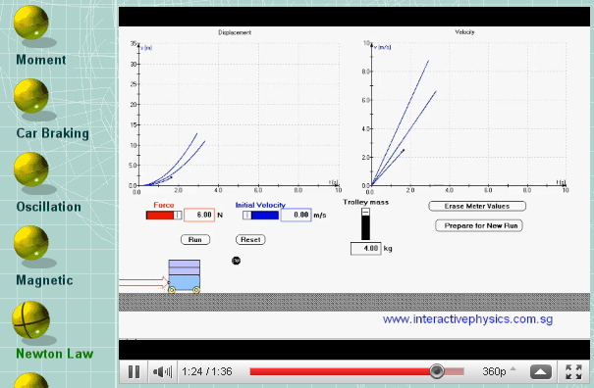
This is a simple example illustrating the use of the formula. F = ma. In general, a body of mass m subject to a force F undergoes an acceleration a that has the same direction as the force, and a magnitude that is directly proportional to the force and inversely proportional to the mass, i.e., F = ma.
By using this computer animation, users can investigate how these two variables F and m (force and mass) affect the motion of the mass. How?
- If you do place a force on an object, it will accelerate, i.e., change its velocity, and it will change its velocity in the direction of the force.
- This acceleration is directly proportional to the force.
For example, if you are pushing on an object, causing it to accelerate, and then you push, say, three times harder, the acceleration will be three times greater.
- This acceleration is inversely proportional to the mass of a given object.
For example, if you are pushing equally on two objects, and one of the objects has five times more mass than the other, it will accelerate at one fifth the acceleration of the other.
Students can display to the screen the main page of this site http://www.interactivephysics.com.sg/newton_second_law.html, and click the link Newton Law for running this demo.
Notice that this example is not displaying the standard user interface by splitting the screen display in four parts as described on these handouts. In fact, the figure below illustrates the display of the user interface as it is required for this case study.
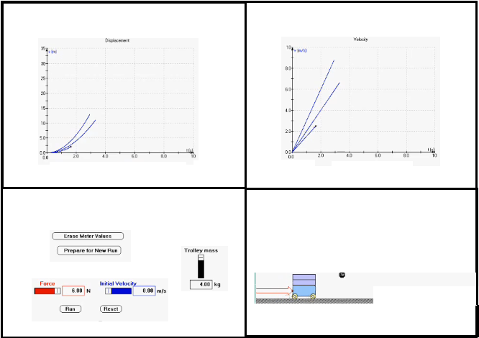
Students must write their own application and their own code else the case study will not be accepted and college procedures will apply. In addition to teacher’s approval, appropriate copyright reference must be provided whenever the course case study is using an existing application and/or any piece of code written by anybody else.
Additional guidelines
- Students will write six animations in total. The two animations appearing under the column Calculus column is compulsory. Then, choose two out of the following three Physics columns Mechanics, Electricity & Magnetism, and Waves and Modern Physics. On each selected Physics column you will find two sub choices (or two animations) making a total of 6 animations for this case study.
- Notice that students will find at least one Open animation question regardless the selected Physics column (one in Mechanics, one in Electricity & Magnetism, and two in Waves and Modern Physics). In this case, students will determine and use a formula of your choice relevant to the selected Physics column; and then, you will specify and use this formula for describing in details the variables involved for animating this formula in every part (see the grading system describing Part I, Part II, Part III and Part IV) of the entire Case Study. The two formulas appearing in the same Physics column must be different.
- This is then the problem for the case study of this course for this semester. Therefore, students will write the algorithm, write the Java/JavaFX code of this algorithm, do the oral presentation, and write the report for this case study by following the deadlines as described on the course outline.
Grading will consider the following:
- Student must do the case study as it is described on these handouts. You can’t make any change unless you have teacher’s approval.
- Teacher will determine team membership and team coordinator in class
- Team membership and team coordinator cannot be changed unless teacher approval. In this case, all team members involved will be penalized by 10% of the final mark for this course.
- Team members can obtain different scores.
- Grading system will apply as described on the course outline.
- The total amount of code submitted by the team must be no less than 90% out of the total amount of code of the entire application else the case study is not accepted
- Team members will estimate and will split the total amount of code proportionally to the number of team members. In this regard, every individual team member will write no less than 90% out of the total individual (ask the teacher to estimate this amount, if you need so) amount of code else no marks are given to this team member and individual contribution for doing the case study is not accepted.
- At the end of the semester, students will submit (in this order) the hard copy of the case study first (the Word file as it is described below), upload this file using Omnivox; and then, do the oral presentation.
- Only the first hard copy of the course study is graded. Omnivox copy is seen as a backup copy of the hard copy; however, it can be used for testing the hardcopy code, as needed. Any additional uploaded hard copy of the case study is ignored and so no marks are given for this piece of work.
- In order to get full marks, the hard copy submitted to the teacher must match to the electronic copy uploaded to Omnivox else it is ignored. No handwritten is allowed
What to hand in
Students will submit to the teacher the hard copy of the Word document named as CSYourName.zip. Replace the text YourName with your name (ex: CSRicardo.zip). This is the content of this file:
- The attached Case Study Cover with the requested information
- An introductory summary description in French of the Case Study (2-3 pages long, 8-10 lines per animation).
- The hard copy showing the entire code followed by the execution results; that is, for each sub choice, submit 3-4 screenshots using good input data for illustrating the expected results, and 2-3 screenshots using critical or invalid input data for illustrating the displaying appropriate messages accordingly.
- In addition, students should upload the electronic version of the file CSYourName.zip to Omnivox.

Interdisciplinary Case Study - Winter 2015
Team Membership

Student Last name First name Signature

1 (coordinator)____________________ ____________________ ___________________

2 ____________________ ____________________ ___________________

3 ____________________ ____________________ ___________________

Case Study Cover - Winter 2015
Team members (Last name First name ID Number)

- ____________________ _____________________ _______________
(Coordinator) (Coordinator) (Coordinator)

- ____________________ _____________________ _______________

- ____________________ _____________________ _______________
Answer to these questions:
Do you use Java? Yes □ Non □ JavaFX Yes □ Non □
Packages Yes □ Non □ . If yes, how many (estimate)? _________
Class Yes □ Non □ If yes, how many (estimate)? _________
Interface Yes □ Non □ If yes, how many (estimate)? _________
Other software | Yes □ Non □ Specify: ________
Do you use any existing code? | Yes □ Non □  If yes, estimate the amount used (in %): ________________
Estimate amount of individual contribution (in %) and team work done |  | Last name First name Contribution in %  (Out of 100%)  1. _____________ _______________ ___________  2. _____________ _______________ ___________  3. _____________ _______________ ___________  Total amount of code submitted by the team: __________  (Total may be less than 100%)
Amount of code missing (in %)

